Lab Assignment 7.4
- (Mutable Default Argument – Function Bug) Task:
Analyze given code where a mutable default argument causes unexpected behavior. Use AI to fix it.
# Bug: Mutable default argument def add_item(item, items= []):
items.append(item) return items
print(add_item(1)) print(add_item(2))
Expected Output: Corrected function avoids shared list bug.
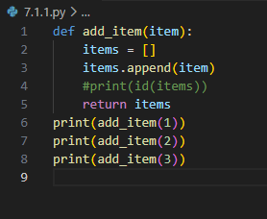

- (Floating-Point Precision Error) Task:
Analyze given code where floating-point comparison fails. Use AI to correct with tolerance.
# Bug: Floating point precision issue def check_sum():
return (0.1 + 0.2) == 0.3 print(check_sum())
Expected Output: Corrected function

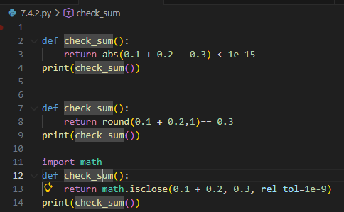

- (Recursion Error – Missing Base Case) Task:
Analyze given code where recursion runs infinitely due to missing base case. Use AI to fix it.
# Bug: No base case def countdown(n):
print(n)
return countdown(n-1) countdown(5)
Expected Output: Correct recursion with stopping condition.
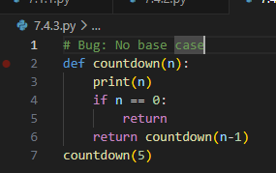
- (Dictionary Key Error) Task:
Analyze given code where a missing dictionary key causes error. Use AI to fix it.
# Bug: Accessing non-existing key def get_value():
data = {"a": 1, "b": 2} return data["c"]
print(get_value())
Expected Output: Corrected with .get() or error handling.

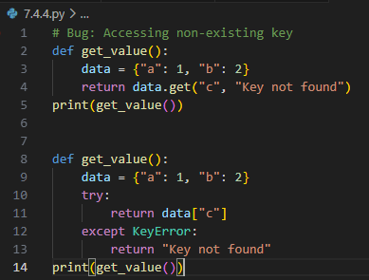

- (Infinite Loop – Wrong Condition)
Task: Analyze given code where loop never ends. Use AI to detect and fix it.
# Bug: Infinite loop def loop_example():
i = 0
while i < 5: print(i)
Expected Output: Corrected loop increments i.
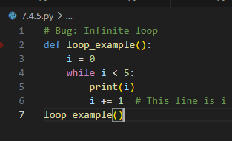
\\\

- (Unpacking Error – Wrong Variables) Task:
Analyze given code where tuple unpacking fails. Use AI to fix it.
# Bug: Wrong unpacking a, b = (1, 2, 3)
Expected Output: Correct unpacking or using _ for extra values.
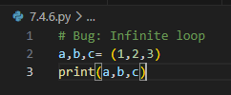
- (Mixed Indentation – Tabs vs Spaces)
Task: Analyze given code where mixed indentation breaks execution. Use AI to fix it.
# Bug: Mixed indentation def func():
x = 5
y = 10
return x+y
Expected Output : Consistent indentation applied.

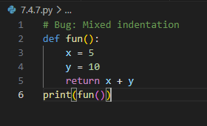

- (Import Error – Wrong Module Usage) Task:
Analyze given code with incorrect import. Use AI to fix.
# Bug: Wrong import import maths print(maths.sqrt(16))
Expected Output: Corrected to import math
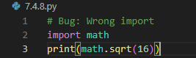

- (Unreachable Code – Return Inside Loop) Task:
Analyze given code where a return inside a loop prevents full iteration. Use AI to fix it.
# Bug: Early return inside loop def total(numbers):
for n in numbers: return n
print(total([1,2,3]))
Expected Output: Corrected code accumulates sum and returns after loop.
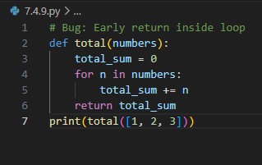
- (Name Error – Undefined Variable) Task:
Analyze given code where a variable is used before being defined. Let AI detect and fix the error.
# Bug: Using undefined variable def calculate_area():
return length * width print(calculate_area())

Requirements:
  - Run the code to observe the error.
  - Ask AI to identify the missing variable definition.
  - Fix the bug by defining length and width as parameters.
  - Add 3 assert test cases for correctness. Expected Output :

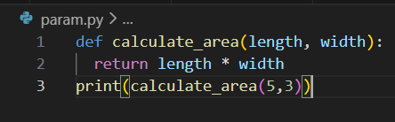

- (Type Error – Mixing Data Types Incorrectly) Task:
Analyze given code where integers and strings are added incorrectly. Let AI detect and fix the error.
# Bug: Adding integer and string def add_values():
return 5 + "10" print(add_values())
Requirements:
  - Run the code to observe the error.
  - AI should explain why int + str is invalid.
  - Fix the code by type conversion (e.g., int("10") or str(5)).
  - Verify with 3 assert cases. Expected Output #6:
  - Corrected code with type handling.
  - AI explanation of the fix.
  - Successful test validation.
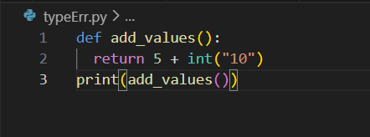
Explanation:
TypeError because of the different data types one should be converted
- (Type Error – String + List Concatenation) Task:
Analyze code where a string is incorrectly added to
# Bug: Adding string and list def combine():
return "Numbers: " + [1, 2, 3] print(combine())
Requirements:
  - Run the code to observe the error.
  - Explain why str + list is invalid.
  - Fix using conversion (str([1,2,3]) or " ".join()).
  - Verify with 3 assert cases. Expected Output:
  - Corrected code
  - Explanation
  - Successful test validation
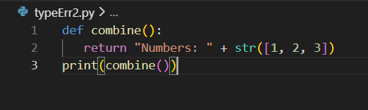
Explanation:
String and list cannot be concatenated together it should be explicitly changed
- (Type Error – Multiplying String by Float)
Task: Detect and fix code where a string is multiplied by a float.
# Bug: Multiplying string by float def repeat_text():
return "Hello" * 2.5 print(repeat_text())
Requirements:
  - Observe the error.
  - Explain why float multiplication is invalid for strings.
  - Fix by converting float to int.
  - Add 3 assert test cases
  - 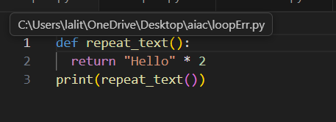

Explanation:
String repetition requires an integer count. Always convert floats explicitly using int() or round() based on your intent—never rely on implicit conversion.

Task 14 (Type Error – Adding None to Integer)
Task: Analyze code where None is added to an integer.
# Bug: Adding None and integer
def compute():
value = None
return value + 10
print(compute())
Requirements:
• Run and identify the error.
• Explain why NoneType cannot be added.
• Fix by assigning a default value.
• Validate using asserts.
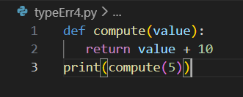

Task 15 (Type Error – Input Treated as String Instead of
Number)
Task: Fix code where user input is not converted properly.
# Bug: Input remains string
def sum_two_numbers():
a = input("Enter first number: ")
b = input("Enter second number: ")
return a + b
print(sum_two_numbers())
Requirements:
• Explain why input is always string.
• Fix using int() conversion.
• Verify with assert test cases.
